**SECTION 1**

**Questions 1 – 10**

Complete the table below.

*Write* ***ONE WORD AND/OR A NUMBER*** *for each answer.*

|  |  |  |
| --- | --- | --- |
| **COOKERY CLASSES** | | |
| **Cookery class** | **Focus** | **Other Information** |
| *Example*  The Food…*Studio*… | how to **1**…………. and cook with seasonal products | ●   small classes  ● also offers **2**…………… classes  ● clients who return get a  **3**…………… discount |
| Bond’s Cookery School | food that is **4**…………. | ● includes recipes to strengthen your **5**………….  ● they have a free **6**……………  Every Thursday. |
| The **7**…………. Center | mainly **8**…………. food | ●   located near the **9**…………..  ● a special course in skills with  a **10**………….. is sometimes available |

**SECTION 2**

**Questions 11 – 13**

Choose the correct letter, **A**, **B** or **C**.

**Traffic Changes in Granford**

**11**   Why are changes needed to traffic systems in Granford?

**A**   The number of traffic accidents has risen.

**B**   The amount of traffic on the roads has increased.

**C**   The types of vehicles on the roads have changed.

**12**   In a survey, local residents particularly complained about

**A**   dangerous driving by parents.

**B**   pollution from trucks and lorries.

**C**   inconvenience from parked cars.

**13**   According to the speaker, one problem with the new regulations will be

**A**   raising money to pay for them.

**B**   finding a way to make people follow them.

**C**   getting the support of the police.

**Questions 14-20**

Label the map below.

*Write the correct letter,* ***A-I****, next to Questions 14-20*

**Proposed traffic changes in Granford**

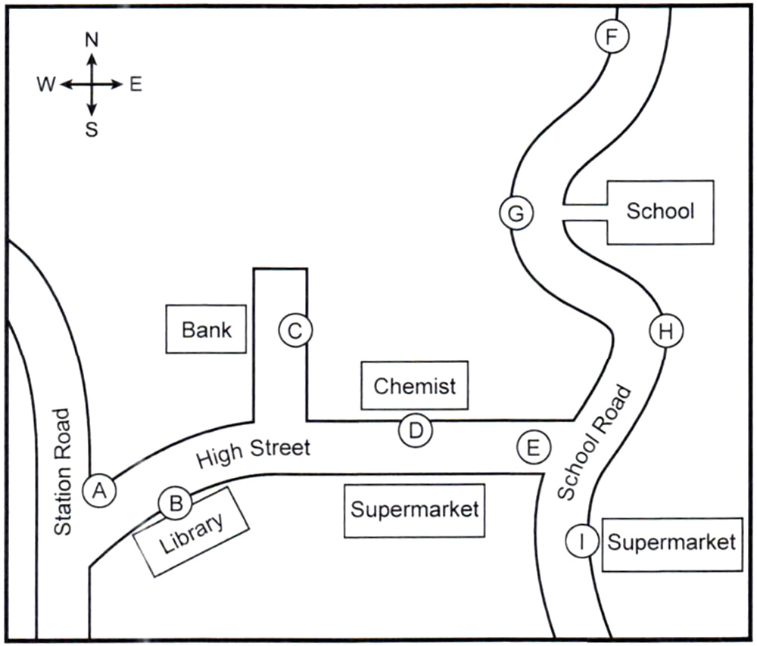

**14**   New traffic lights ………….

**15**   Pedestrian crossing ………….

**16**   Parking allowed ………….

**17**   New ‘No Parking’ sign ………….

**18**   New disabled parking spaces ………….

**19**   Widened pavement ………….

**20**   Lorry loading/unloading restrictions ………….

**SECTION 3**

**Questions 21 – 25**

Choose the correct letter, **A**, **B** or **C**.

**21**   Why is Jack interested in investigating seed germination?

**A**   He may do a module on a related topic later on.

**B**   He wants to have a career in plant science.

**C**   He is thinking of choosing this topic for his dissertation.

**22**   Jack and Emma agree the main advantage of their present experiment is that it can be

**A**   described very easily.

**B**   carried out inside the laboratory.

**C**   completed in the time available.

**23**   What do they decide to check with their tutor?

**A**   whether their aim is appropriate

**B**   whether anyone else has chosen this topic

**C**   whether the assignment contributes to their final grade

**24**   They agree that Graves’ book on seed germination is disappointing because

**A**   it fails to cover recent advances in seed science.

**B**   the content is irrelevant for them.

**C**   its focus is very theoretical.

**25**   What does Jack say about the article on seed germination by Lee Hall?

**A**   The diagrams of plant development are useful.

**B**   The analysis of seed germination statistics is thorough.

**C**   The findings on seed germination after fires are surprising.

**Questions 26-30**

Complete the flow-chart below.

*Choose* ***FIVE*** *answers from the box and write the correct letter,* ***A-H****, next to Questions 26-30.*

|  |  |  |  |
| --- | --- | --- | --- |
| **A**   container | **B**   soil | **C**   weigh | **D**   condition |
| **E**   height | **F**   colour | **G**   types | **H**   depths |

**Stage in the experiment**

Select seeds of different **26**…………….. and sizes.

↓

Measure and record the **27**…………….. and size of each one.

↓

Decide on the **28**…………….. to be used.

↓

Use a different **29**…………….. for each seed and label it.

↓

After about 3 weeks, record the plant’s **30**………………

↓

Investigate the findings.

**SECTION 4**

**Questions 31 – 40**

Complete the notes below.

*Write* ***ONE WORD ONLY*** *for each answer.*

**Effects of urban environments on animals**

**Introduction**

Recent urban developments represent massive environmental changes. It was previously thought that only a few animals were suitable for city life, e.g.

●   the **31**…………….. – because of its general adaptability.

●   the pigeon – because walls of city buildings are similar to **32**…………….. .

In fact, many urban animals are adapting with unusual **33**…………….. .

**Recent research**

●   Emilie Snell-Rood studied small urbanised mammal specimens from museums in Minnesota.

– She found the size of their **34**…………….. had increased.

– She suggests this may be due to the need to locate new sources of **35**……………. and to deal with new dangers.

●   Catarina Miranda focused on the **36**……………… of urban and rural blackbirds.

– She found urban birds were often braver, but were afraid of situations that were **37**……………

●   Jonathan Atwell studies how animals respond to urban environments.

– He found that some animals respond to **38**……………… by producing lower levels of hormones.

●   Sarah Partan’s team found urban squirrels use their **39**…………….. to help them

communicate.

**Long-term possibilities**

Species of animals may develop which are unique to cities. However, some changes may not be **40**…………….. .